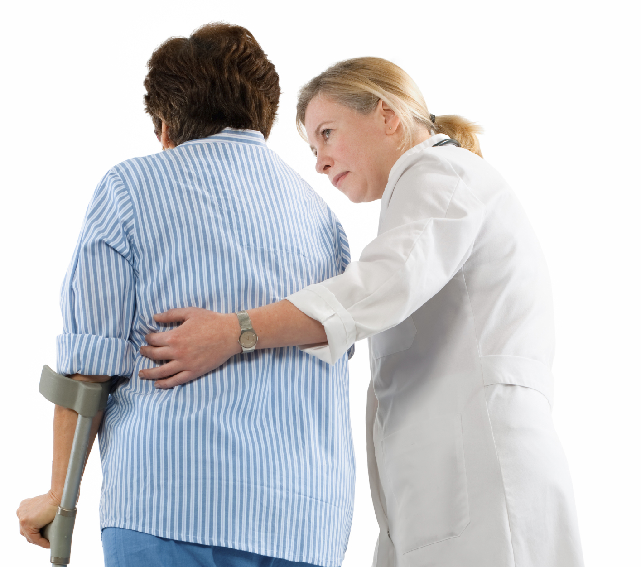

Safe Patient Handling & Mobility Program
Company name here

I. Introduction

As part of the organization’s overall safety and health program, a Safe Patient Handling and Mobility program has been established. This program is designed to meet the latest industry practices.

II. Objective

The objective of the Safe Patient Handling and Mobility program is to:

Ensure that patients are cared for safely while maintaining a safe work environment for our employees.

Facilitate the safe use of transfer aids and equipment.

Provide an objective, easy to understand, consistent means of evaluating resident transfer needs.

Provide a consistent technique for the assisting, repositioning or transfer of patients.

Encourage maximum participation within a Lift-Free program.

III. Scope

The Safe Patient Handling and Mobility program applies to all employees who handle and/or move patients. Applicability of this policy includes but is not limited to the following examples:

Transferring tasks such as from bed to wheelchair or wheelchair to toilet

Lifting patients to change clothing, change bed linens

Repositioning tasks in wheelchairs or beds

Bathing patients

Turning patients in bed

Holding limbs or body parts during surgical procedures

Lateral transferring patient from bed to cot or gurney

Placing patients on cots or gurney during ambulance call

<Insert program coordinator title> has the responsibility for overall coordination, administration and implementation of the Safe Patient Handling and Mobility Program, and is designated the program coordinator.

The Safe Patient Handling and Mobility Program has six major components:

1. Written program

2. Objective criteria and patient assessments

3. Quality assurance through observation of staff

4. Employee training and skill assessments

5. Maintenance of equipment

6. Accountability

IV. Objective Criteria and Patient Assessment

Patient assessments are critical to the success of this program. All patients will be assessed by the admitting nurse when the patient is admitted to the hospital. The paramedic or lead EMT will perform an assessment before loading a patient onto the cot for emergency calls. Assessments will be completed weekly for admitted patients or as needed based on the care plan.

Patient Assessments should include an assessment of each patient’s transferring needs and the most appropriate lifting and transferring method(s) that should be prescribed based upon the patients ability to ambulate, bear weight, follow verbal instructions and their rehabilitation goals.

The patient care environments should also be assessed to examine the layout of the patient care rooms, bathrooms and bathing areas to identify factors that might contribute to patient handling incidents. Some of these factors are:

Furniture that might interfere with transfers

The adjustability of the bed height

The size of the bathroom and bathing area

Physical barriers such as door thresholds that might restrict the movement of lifting equipment

<insert specifics to your organization>, for example: Patients requiring a sit-to-stand lift or total lift should not be assigned rooms in the west wing of the building. The restrooms in this wing have a curb preventing the lift from entering the shower stall.>

Admitting staff and ambulance staff should be aware that bariatric patients need special consideration. Bariatric patients are defined as persons weighing more than 100 to 200 pounds over a normal body weight, or in excess of 300 pounds. <This paragraph needs to be specific to your organization> “They will need to be assigned to room 145C or 147C. These rooms have beds, toilets and lifts to accommodate the weight of the patient. If additional bariatric patients are expected, additional beds and equipment will need to be ordered from ABC Durable Goods Company”.

Objective Criteria
Only staff who have received specific training or have the expertise to quantify a patients transfer abilities should have the discretion to do so. Staff which have the skill set may include; nurses (LPNs and RNs), EMTs, paramedics and the physical therapy staff. Only these individuals would have the ability to change a patient’s care plan to reflect a less assistive method i.e. allowing a sit to stand lift to be used instead of a total lift, or a gait belt transfer instead of a sit to stand lift. Any caregiver can at any time increase the level of transfer to a more assistive method from what is stated in the care plan, based on the ability of the resident to assist or comprehend the transfer (i.e. a sit-to-stand lift could be increased to a total lift if the patient is weak at that time).

Objective criteria (See Appendix A) to be used to determine the transferring of residents:

1. Resident can be standing for four seconds, bearing weight without assistance → Walking belt/gait belt transfer

2. Resident can stand for less than four seconds, bearing weight with some assistance → Sit-to-stand transfer

3. Resident is Non-weight bearing → Total transfer

4. Fallen resident. → Total transfer (unless resident can get up on his or her own)

5. Lateral transfers or repositioning → Lateral transfer devices (LTD) or friction-reducing devices (FRD) to be used for draw sheets, trash bags or incontinence pads (DO NOT constitute FRD or LTD)

6. Two persons must be present for all mechanical-aided transfers

Refer to the algorithms located in Appendix A for the criteria.

Patient Indicator System
<This paragraph needs to be specific to your organization> The type of transfer and lift method to be used by staff for each patient is indicated in the patient care plan and through the use of the Patient Indicator system (PI). The PI is designed so the employee can immediately identify the mobility level of the patient by looking at the PI emblem above the patient’s bed.

Green Star = Independent, may ambulate on their own

Yellow Circle = Walking/gait belt required for ambulation

Red Circle = Two-person gait belt transfer

Yellow Triangle = Sit-to-stand lift

Red Triangle = Total Lift Safe Patient Handling and Mobility Program

V. Quality Assurance

To ensure quality patient care and to maintain employee safety standards, all staff expected to perform safe patient handling and mobility will undergo an unannounced skill observation each quarter for each type of handling method they perform. The observation must be documented. The observer has the option of using the Resident/Patient Transfer – In-Room Observation form in Appendix B, or the Safe Patient Handling & Mobility Performance Checklist in Appendix C.

Shift supervisors (or whoever is designated as the quality assurance staff) will perform observations each month for their staff. They will develop a schedule whereby each employee is observed quarterly for each type of transfer and by year’s end will have observed all their employees performing all the transfer methods at least four times. All staff performing skill observations shall send the completed documentation forms to the program coordinator.

The program coordinator will oversee the quality program and file the Resident/Patient Transfer – In-Room Observation forms. The forms will be kept for three years. <This time period is discretionary; you may establish your own>

All patient handling incidents including injuries to patients and employees will be reviewed. The review team will give recommendations and corrective actions to prevent future occurrences.

VI. Training Program

Effective employee training and education is the most critical component of the Safe Patient Handling and Mobility program. A properly conducted training program will ensure that employees are aware of hazards in the workplace, the appropriate control measures to protect themselves and create a safer environment for our patients.

The program coordinator will coordinate the employee training and education program for the organization.

Patient Assessment
Education and competency in patient assessment will be completed upon initial employment and annually. This includes all staff expected to perform assessments, including but not limited to:

Physicians

Nurses

Physical & Occupational and Restorative Therapists

Paramedics

Ambulance Lead Staff

Safe Patient Handling and Mobility

Education and competency in safe patient handling and mobility will be completed for the following circumstances:

All new hires, before being assigned to a floor and/or transferring, regardless of experience upon initial employment

After all transfer-related incidents

After an employee has been off of work on a leave lasting longer than 90 days

Annually

This training includes all staff expected to handle and move patients, including but not limited to:

Physicians

Nurses

Aides

Physical, Occupational & Other Therapists

Paramedics, EMTs Safe Patient Handling and Mobility Program

X-ray/Scan Technicians

Training topics will include, but not be limited to;

Dealing with combative patients during transfers

Use of mechanical lifts

Use of lateral transfer devices

Gait belt transfers

Repositioning of residents in wheelchair, chair or bed

Transfer reduction and/or planning of transfers

Daily inspection of equipment and slings

Return demonstrations will be used to ascertain staff know and understand the concepts of this program and how to use each piece of equipment. The Performance Checklist in Appendix C will be used to document the skill observations.

VII. Storage, Maintenance and Inspection Program

The Environmental Services <OR Enter Your Department Responsible> department is responsible for the periodic inspections and maintenance of the lift equipment and slings. The Sit-to-Stand and Total Lift equipment shall be inspected monthly. The employee inspecting the equipment must follow the guidelines provided by the lift manufacturer. Any defects noted which may affect the performance of the equipment must be identified and the equipment tagged and removed from service.

A spare battery for lift equipment shall be charged and readily accessible to all applicable employees. <The batteries are stored with a charger in the linen closet on each floor.>

<The lifts are stored in empty patient rooms in the wing that are assigned to.> They should not be stored in an occupied room or in the hallway. They create congestion in the hallways and are tripping hazards. All employees shall ensure the slings used with mechanical lift equipment are also visually inspected each day before use. The employee shall look for loose threads, fraying material and holes worn in the fabric. These inspections are not documented. If the employee notes any questionable wear, they should remove the sling from service and give it to their supervisor.

Please see Appendix D for an inspection checklist.

VIII. Accountability

The Environmental Services <OR Enter Your Department Responsible> department is responsible for the periodic inspections and maintenance of the lift equipment. The Sit-to-Stand and Total Lift equipment shall be inspected monthly. The employee inspecting the equipment must follow the guidelines provided by the lift manufacturer. Any defects noted which may affect the performance of the equipment must be identified and the equipment tagged and removed from service.

This program is very important for the safety of our patients and employees. Employees not following these procedures
Appendix A
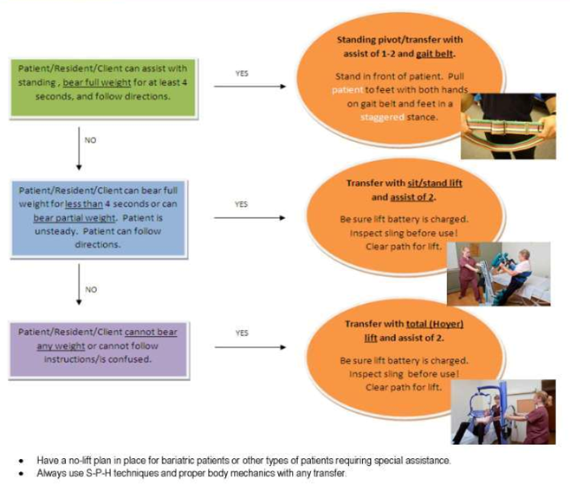
LC-1413 Safe Patient Handling Objective Transfer Criteria

Objective transfer criteria continued
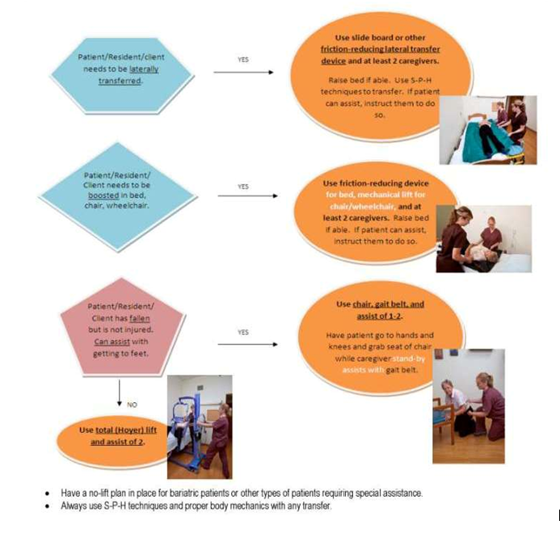
Appendix B
LC-1423 Resident/Patient Transfer – In-Room Observation
Room # / Bed #: |  | Time Observed:
Staff being observed:
Equipment being used:
Was the staff following the plan of care? If not, explain in detail. |  | Yes No N/A
Comments:
Did caregiver know and understand the objective criteria? |  | Yes No N/A
Were proper body mechanics used at all times? |  | Yes No N/A
Is there adequate equipment available? |  | Yes No N/A
Is the equipment easily accessible? |  | Yes No N/A
Is the equipment clean and in good repair? |  | Yes No N/A
Were extra batteries available? |  | Yes No N/A
Did the caregiver inspect the equipment and slings prior to use? |  | Yes No N/A
Were proper slings available for the desired equipment? |  | Yes No N/A
If you answered no to any of the above questions, provide details.
Offer your input as to what could be done differently or better to ensure resident/patient and employee safety:
Name of person doing to QC check:
Signature: |  |  | Date:
Supervisor – detail corrective actions taken:
Signature: |  |  | Date:

Appendix C
LC-1440 Safe Patient Handling and Mobility Performance Checklist
Injury-Free Transfer Procedures
Whenever a caregiver will assist a resident with a transfer or use a mechanical lift, they should plan the procedure before approaching the resident. This includes clearing the area of items that could interfere with a safe procedure. Always make sure the resident has on the proper footwear and that, if applicable, laces are tied. Brakes of the wheelchair should always be locked.

Gait Belt Transfer (one person)
Transfer procedure for residents who are able to bear weight for four seconds or more (or specific objective criteria for facility) and are predictable.
Check if appropriately completed:
Tells the resident who they are and what they are going to do. If the resident is able to comprehend, asks if he or she understands.
Raises the height of the bed to an appropriate level.
Asks the resident to “scoot” forward on the bed, chair, etc.
Places the belt around the resident’s waist and fastens snuggly enough that it will not slip around the ribs (allow two fingers space). Never place belt on bare skin.
Enlists the help of the resident. Talks to the resident throughout the procedure. Allows him/her to do as much as possible.
Grips the belt with palms facing upward.
Tells the resident that “on the count of three” the transfer will be done.
Maintains good body position in front of the resident, places one foot between the feet of the resident and stays as close to the resident as possible while keeping back straight.
Gently “rocks” resident forward and backward while counting, “one, two, three.”
Assists resident into a standing position by pulling and getting their “nose over toes” – does not lift!

Comments/Concerns
Successfully completed
Needs more training

Other:

Employee signature/Date Trainer signature/date
Sit-to-Stand Mechanical Lift
Transfer procedures for residents who can bear weight for less than four seconds (or objective criteria applicable to facility) or are unpredictable with their weight-bearing capabilities.

Check if appropriately completed:
Two caregivers to assist at all times.
The sling and lift should be inspected prior to use.
Informs resident who they are and what they are going to do.
Raises the height of the bed to an appropriate level.
Places lift in front of resident and, if able, asks resident to place feet on the foot plate (or assists them as necessary).
Places strap around lower legs.
Places sling around resident; uses appropriate loop.
Secures belt around resident’s waist.
One caregiver stays by resident and ensures the sling is secure and the standing motion is safe. The resident’s arms must be on the outside of the sling.
The resident should hold onto the grab bars throughout the transfer.
Second caregiver operates the controls to bring resident to a standing position.
The caregiver by the resident tightens the belt once the resident is slightly up from the sitting position.
If transferring to another location (w/c, bed), caregiver by resident assists in turning the lift while the caregiver by the controls pushes/pulls the lift. The caregiver should try to avoid turning the lift, if possible.

Comments/Concerns
Successfully completed
Needs more training

Other:

Employee signature/Date Trainer signature/date
Total Lift
Resident transfers for all non-weight-bearing or significantly contracted residents should be done using a total lifting device.

Check if appropriately completed:
Brings equipment to the bedside, uses proper size sling for the resident. The sling and lift should be inspected. Evaluates the resident and explains the lift procedure to the resident.
A caregiver on each side of the bed. There must be two caregivers present for this. The height of the bed is adjusted into a “safe work zone” for caregivers.
Rolls resident toward one caregiver; places the sling so that it is low on (under) the resident’s back. Caregiver may need to fold the sling lengthwise in order to bring the leg stirrup or pads out and under the thighs – and then cross the straps unless resident’s physical condition prohibits this.
Rolls the resident toward the second caregiver across the sling so the resident is squarely in the center.
Secures wheelchair (if applicable) from movement.
Rolls the lift to the side of the resident’s bed. Opens the base of the lift to its widest point. Places the base under the bed so the guide handles are next to the bed and the overhead bar of the lift is directly over the resident. The second caregiver grabs the bar as the lift is lowered so it does not strike the resident.
Hooks the loops onto the bar of the lift according to the size of the resident.
Provides support for the resident’s head if there isn’t a head support on the sling.
Checks all connections on the lift to be sure that they are secure and will support the resident.
Raises the resident off the bed. One caregiver operates the controls and uses one hand to assist with guarding the lift. The other caregiver uses both hands to control the lift.
When the sling is high enough to move the resident easily and safely, rolls the lift away from the bed.
Rolls the lift over to the chair until the chair is inside the base of the lift, directly under the sling. The caregiver should try to avoid turning the lift, if possible
Slowly turns and lowers the resident gently into the chair.
When the resident is securely seated, releases the attachments. Removes the sling from under the resident and rolls the lift out of the way. To remove the sling: Lift one leg of the resident at a time and slide the sling outward and remove. Explain to the resident what you are doing and ask him/her to lean forward so you can slip the sling upward. Note: For a very large resident, you may have to leave the sling in position under the resident until they are transferred back into the bed.
Allows the resident to remain seated according to the physician’s orders. Makes certain the resident is comfortable and is sure the call button is easily within reach for the resident.
Washes hands after the procedure is complete.

Comments/Concerns
Successfully completed
Needs more training

Other:

Employee signature/Date Trainer signature/date

Use of Lateral Transfer Device

Check if appropriately completed:
Has a caregiver on each side of the bed.
Raises the height of the bed to an appropriate level.
Informs resident who they are and what they are going to do.
Rolls resident toward one caregiver; places the lateral transfer device under the drawsheet/incontinence pad. Assure lateral transfer device covers the shoulder to the resident’s hips.
Rolls the resident toward the second caregiver across the lateral transfer device so the resident is squarely in the center.
Counts to three to initiate the transfer.
Utilizes proper body mechanics.
Grasps onto the friction-reducing device lateral and slides to second bed/cart.

Comments/Concerns
Successfully completed
Needs more training

Other:

Employee signature/Date Trainer signature/date

Repositioning/Boosting (Bed)

Check if appropriately completed:
One caregiver on each side of the bed. Bed should be raised to appropriate height.
Attempts to have resident assist, if able, by bending knees up and pushing when attempting to boost.
If unable to assist, places a friction-reducing device underneath the resident.
Rolls resident by positioning arm and leg toward the side being rolled. Then places hands on shoulder and hip to facilitate rolling. Then places a friction-reducing device underneath the drawsheet/incontinence pad.
Rolls resident to other side utilizing the same technique and pulls the friction-reducing device through.
Each caregiver places one hand at shoulder and one at hip. Grasps onto the friction-reducing device with the palms up.
Caregivers count to three to initiate the repositioning.
Caregivers shift weight of body to reposition and slides the resident to desired position rather than lifting and repositioning.
Friction-reducing device is removed after repositioning utilizing the same rolling techniques.

Comments/Concerns
Successfully completed
Needs more training

Other:

Employee signature/Date Trainer signature/date

Laying to Sitting (one or two caregivers, depending on size of resident)

Check if appropriately completed:
Raises the height of the bed to an appropriate level.
Raises shoulders and upper body to sitting position.
Elicits help from resident.
Rolls resident to their side (e.g., arm over, legs over).
Places one hand by resident’s shoulder and one by hip.
Raises resident’s shoulders.
Lowers legs off bed.

Comments/Concerns
Successfully completed
Needs more training

Other:

Employee signature/Date Trainer signature/date

Post-Fall Transfer
Purpose – To ensure the safety of staff and residents after resident falls.

Policy – All staff will use a mechanical lift in transferring resident from floor if resident is unable or incapable of standing up on their own.

Check if appropriately completed:
Immediately after fall, licensed staff member must assess resident for possibility of injury.
After licensed nurse has completed assessment and determined there is no evidence of injury that would prohibit transfer, then proceed.
Brings equipment to the resident. Utilizes the proper size sling for the resident. Evaluates the resident and explains the lift procedure to the resident.
A caregiver on each side of the resident. There must be two caregivers present.
Rolls resident toward one caregiver; places the sling so it is low on (under) the resident’s back. Caregiver may need to fold the sling lengthwise in order to bring the leg stirrup or pads out and under the things, and then cross the straps unless resident’s physical condition prohibits this.
Rolls the resident toward the second caregiver across the sling so the resident is squarely in the center.
Secures wheelchair (if applicable) from movement.
Rolls the lift to the side of the resident. Opens the base of the lift to its widest point.
Hooks the loops onto the bar of the lift according to the size of the resident.
Provides support for the resident’s head if there isn’t a head support on the sling.
Checks all connections on the lift to be sure that they are secure and will support the resident.
Raise the resident off the floor. One caregiver operates the controls and uses one hand to assist with guiding the lift. The other caregiver uses both hands to control the lift.
When the sling is high enough to move the resident easily and safely, rolls the lift away to either a bed or wheelchair.
Slowly turn and lower the resident gently into the chair/bed.
When the resident is securely seated, release the attachments. Remove the sling from under the resident and roll the lift out of the way. To remove the sling: Lift one leg of the resident at a time and slide the sling outward and remove. Explain to the resident what you are doing and ask him/her to lean forward so you can slip the sling upward. Note: For a very large resident, you may have to leave the sling in the position under the resident until they are transferred back into the bed.

Comments/Concerns
Successfully completed
Needs more training

Other:

Employee signature/Date Trainer signature/date

Appendix D
LC-1424 Sling Safety Inspection and Care
A critical component used in every safe resident/patient transfer is the sling. Slings come in many shapes and sizes that are used in numerous resident/patient functions, including vertical and horizontal transfers, toileting, bathing, limb support and ambulation training. Whatever the use, their overall condition and care is important to their safe use. Slings and lifting systems have to be 100% reliable – and their quality, safety and comfort are important aspects to their reliability. Slings can carry heavy loads, are laundered often and are used multiple times throughout the day. To ensure their safe, comfortable use, slings should be carefully maintained and regularly inspected for wear and overall condition. This bulletin will help to address the proper means to inspect and care for your slings to ensure long life and safe condition. Always consult the sling manufacturer to follow their prescribed maintenance and inspection protocols.

Ineffective care and maintenance of slings can result in resident/patient falls, head injuries or even death. Care should be taken to ensure the lift and sling selected for the job at hand have the lifting capacity to accomplish the task, the sling is the correct style for the task and the lift and sling are in good working order. The sling represents the link between the resident/patient and the actual lifting device. The sling should be inspected prior to each use. A documented monthly inspection program should be established to formally inspect all sling in house to ensure they are in good working order. Most manufacturers provide a “lifespan” for their slings. Please consult your sling manufacturer and observe this specified guideline. Numerous factors affect the lifespan of the slings and the useful life of the sling may be shorter than the manufacturer specifies based on the slings condition, laundering frequency, water temperature, disinfectant, frequency of use, resident/patient weight or other potential factors. Actual strength testing of slings to determine their overall condition is not an achievable inspection method as this form of testing would ultimately damage the sling. Visual inspection is a means to subjectively assess the slings overall condition and ability to continue to perform its task.

Monthly Visual Sling Safety Inspection Document
The chart attached can represent the documentation maintained for the monthly sling inspection. Each sling that is available for services should be thoroughly inspected (excluding new unused sling in their original bags) monthly. Remember though, all slings should be visually inspected prior to each use to ensure safe condition. Note: The sling model number and serial number, sling location, inspected by and overall condition (G – good, F – fair, R – replace). Comments on confitio0n can be added in the comments area. The inspection form should be located in a central location where other inspection documents are maintained. Consideration should be given to maintaining both equipment and sling inspection forms in three-ring binders in this central location for ready reference on equipment/sling maintenance.

How to Visually Inspect a Sling
- Lay the sling out on a flat surface so all areas of the upward side are visible.
- Begin by inspecting the loops for their connection and stress points. Turn and twist the loops inspecting for signs of fraying, pulled stitching, tearing or other signs of damage.
- Check the stitching on all seams and the edge of the sling for fraying or loose stitching.
- Inspect the sling for heat damage. This can be observed as an overall shrinking of the sling, sections that may have shrunk or show signs of scrunching. Run your hands over the sling feeling for areas of brittle or stuff feel to the fabric.
- Inspect the body of the sling for rips or holes.
- Inspect the slings for excessive staining. Some may occur through incontinent residents/patients, others may indicate an exposure to chemicals.
- Check the sling for signs of exposure to bleach. This can be determined by fading of the fabric, labels, straps, etc. Any sling laundered in bleach should be removed from service.
- Inspect both sides of the sling.

Monthly Sling Inspection Form

Year 20__ | Jan. | Feb. | March | April | May | June | July | Aug. | Sept. | Oct. | Nov. | Dec. | Comments
Sling model number
Sling location
Inspected by
Sling condition G/F/R
Sling model number
Sling location
Inspected by
Sling condition G/F/R
Sling model number
Sling location
Inspected by
Sling condition G/F/R
Sling model number
Sling location
Inspected by
Sling condition G/F/R
Sling model number
Sling location
Inspected by
Sling condition G/F/R
Sling model number
Sling location
Inspected by
Sling condition G/F/R
Sling model number
Sling location
Inspected by
Sling condition G/F/R

Appendix E
LC-1422 Transfer Equipment Inspection Report
Equipment | Unit - #/Location | Condition | Observation
Mechanical Lifts
Slings
Sit-to-Stand Lifts
Slings
Shower Chairs
Lateral Transfer Devices
Friction-Reducing Devices
Adjustable Low Beds
Non-Adjustable Low Beds
0 = Not Used 1 = Poor 2 = Fair 3 = Good 4 = Excellent

Maintenance Issues:

Storage Requirement Issues:

Inspected by: | Date:

Appendix F
Safe Patient Handling & Mobility Training Log

Instructor: Date:
I have trained the employees listed below on the Safe Patient Handling and Mobility Program. Supervisors must attach a copy of the training outline. It must be known if the training was for the full program or for specific components of the program.
Instructor’s Signature:
I have received information on the above-mentioned topic. I understand the information and have no further questions on this topic.
Employee’s Name | Employee’s Signature | Department | Date

