Registration for Online Safety and Human Resources Courses
- Visit CompWestInsurance.com and click on “Toolbox” in the top right navigation.
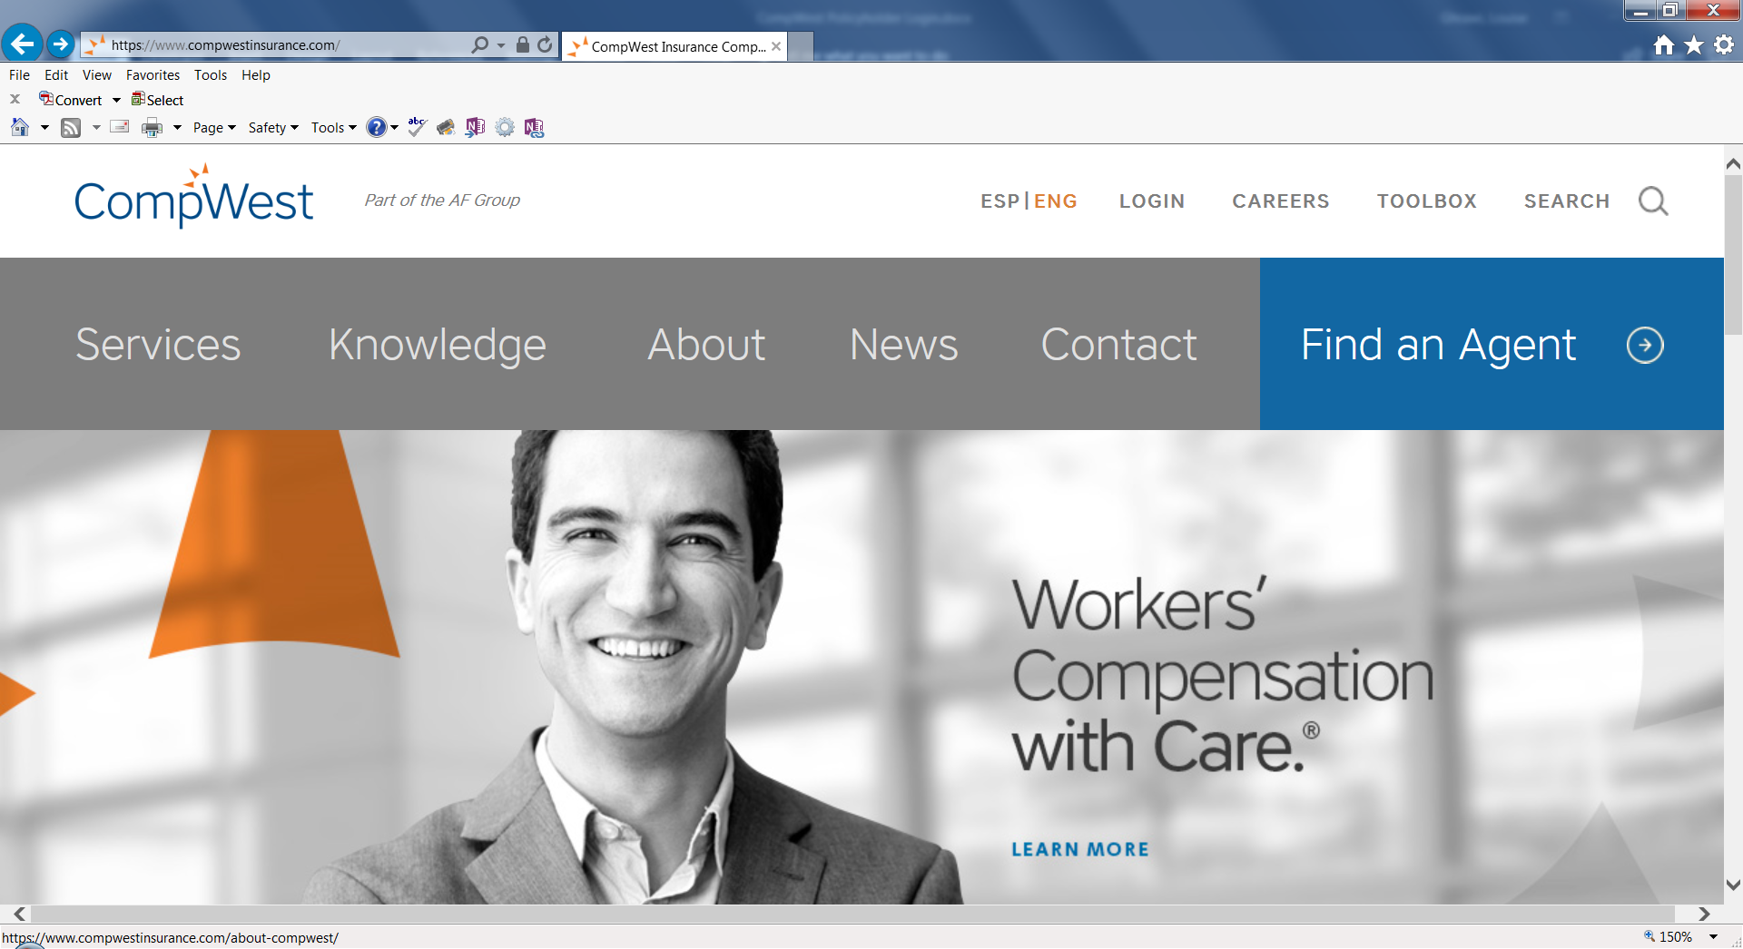

- Under the “Loss Control” menu, click “Safety Training.”
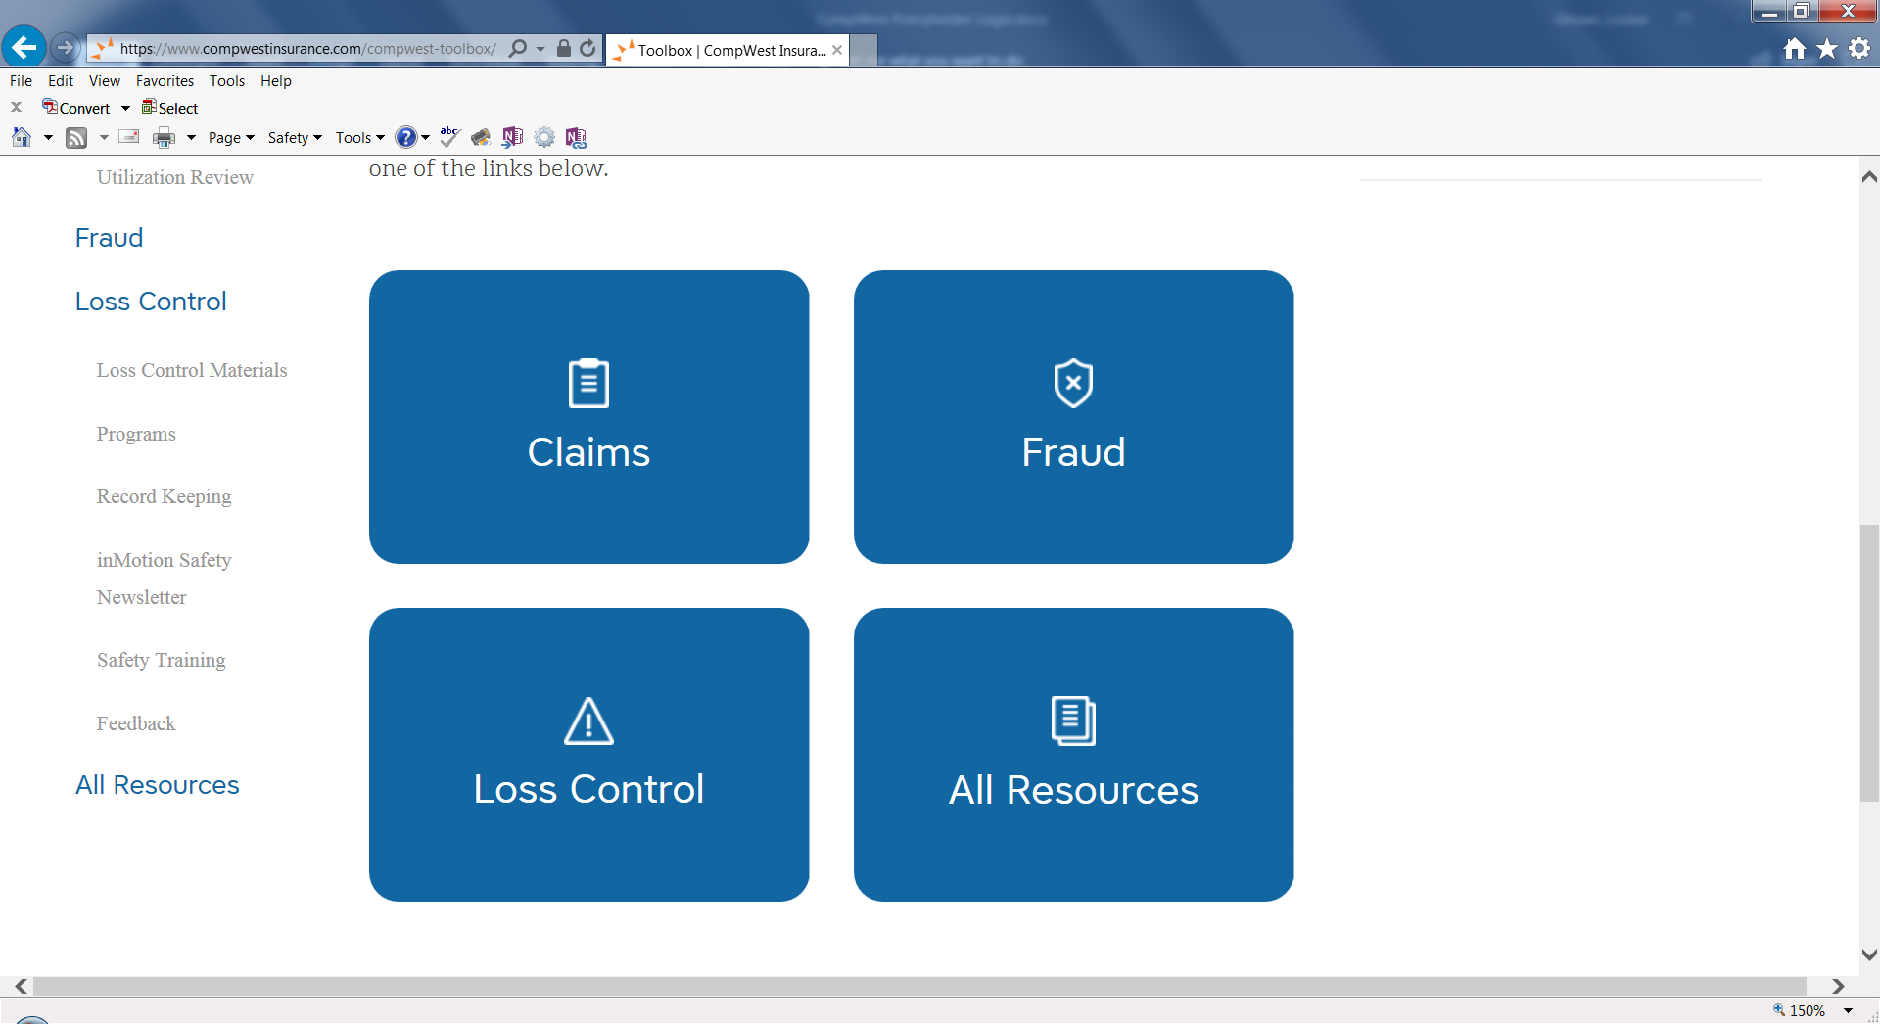
- Under “Safety Training Links,” click “Register.”
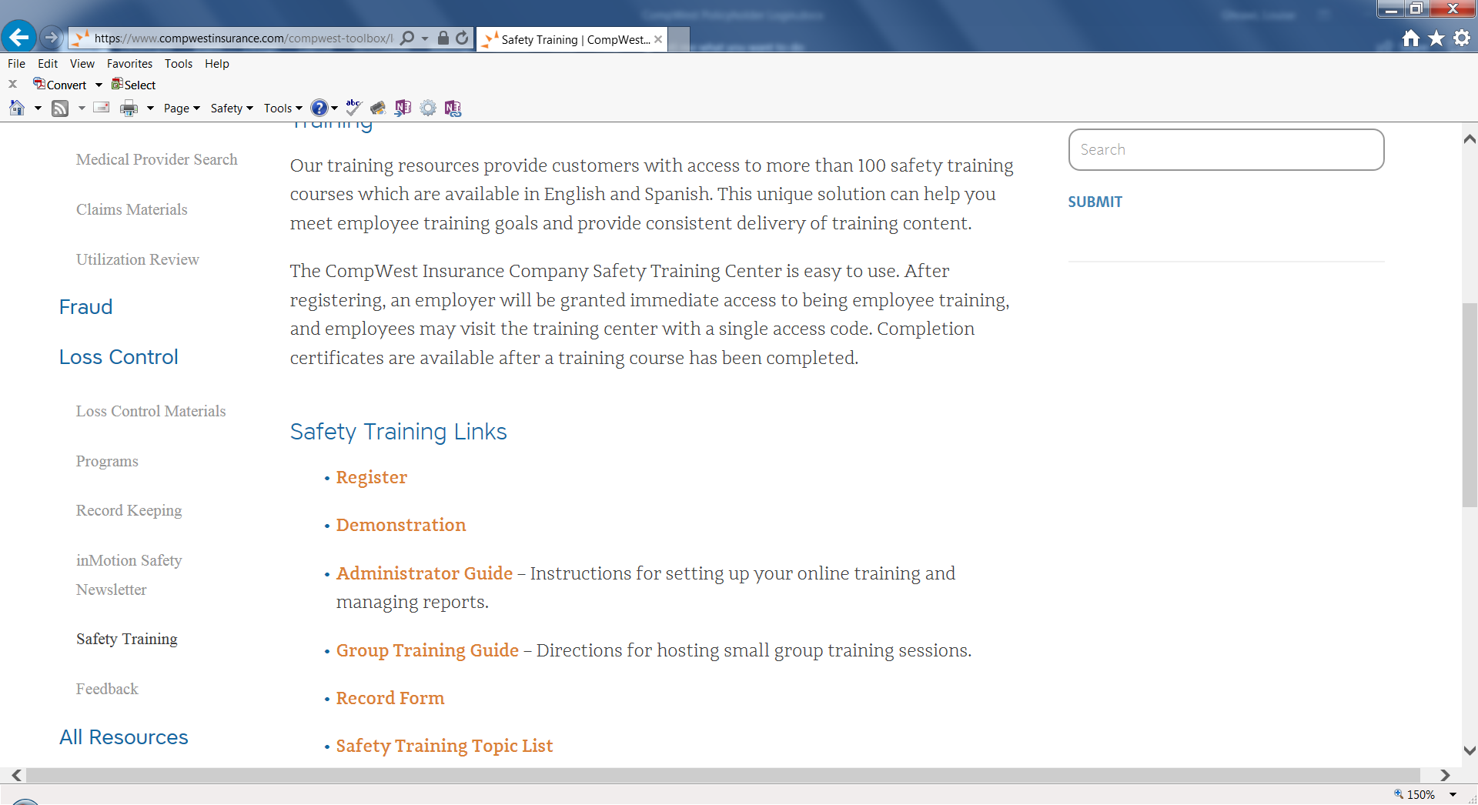
- Complete the registration form, then click “Submit” at the bottom of the page.
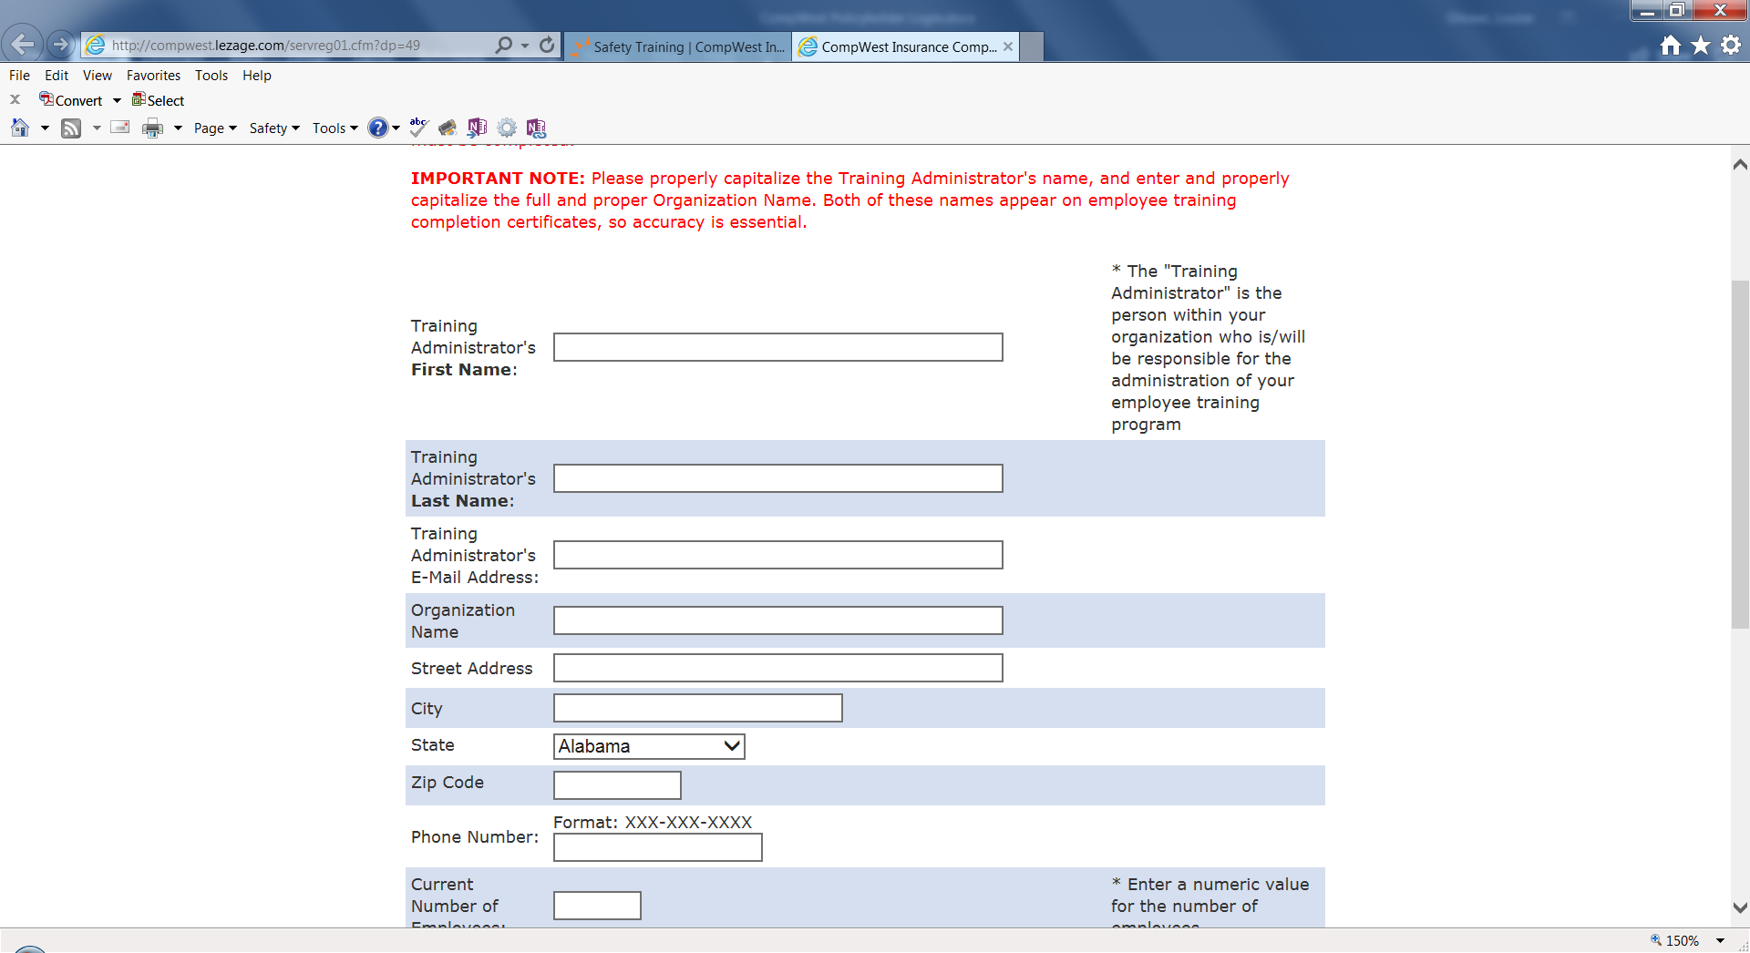

Course Access
Once you submit the form, the system will generate two login links and passcodes — one for the administrator (the individual responsible for assigning and tracking training) and one for employees.
The email will be sent from system@lezage.com. Please retain this access email; it is how administrators and employees will access courses from this point forward.
The email will look like this:
IMPORTANT: Please record the following information in a safe and secure location (do not place links/access codes where accessible by the public).
CompWest Insurance Company provides our clients with access to the CompWest Safety Training Center. This valuable service provides a variety of online training courses, and we're confident that it will enhance your employee training program and assist you in meeting the responsibilities imposed by federal and state regulations.
As the training administrator for your firm, please use the following login page link and access code for the service. After access, you will be able to (1) view an online, narrated presentation, which provides more information on the service; (2) print employee training completion certificates for documentation purposes; and (3) run employee training reports.
Links and access codes have been deleted for the purposes of this tutorial.
Training Administrator Login Page Link: http://compwest.lezage.com/tadmin/login.cfm
Training Administrator Access Code: Y2RY693W
For training purposes, each of your employees will use the following Login Page Link and a single Employee Access Code to take training courses.
Employee Login Page Link: http://compwest.lezage.com/login.cfm?dp=49
Employee Access Code: 5PE7Y8LH
Please remember that you must NOT publish these links and access codes in a publicly accessible location.
Your Service Sponsor: CompWest Insurance Company
Your Account Information:
CompWest Insurance
3 Hutton Center Drive, Suite 600
Santa Ana, CA 92707
Training administrator name: Louise Ghrawi
Training administrator email: lghrawi@compwestinsurance.com
Training administrator phone: 714-641-9556

