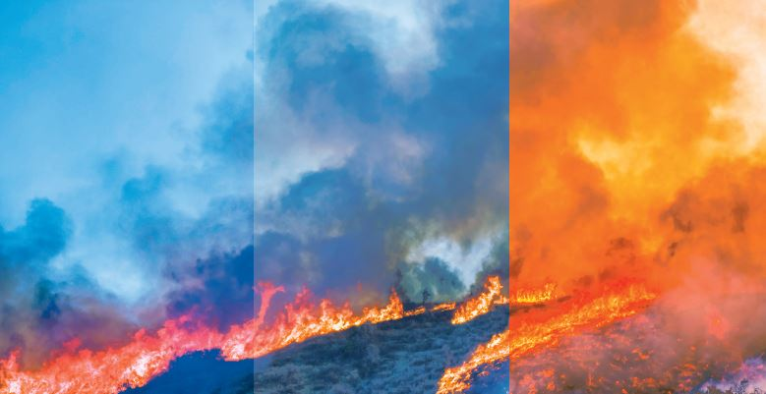
Wildfire Protection Program
Protect Your Lungs from Wildfire Smoke and Ash

Company name here

Due to California wildfires and poor air quality, 5141.1 was enacted as an emergency ruling and remains in effect. While the standard is not finalized, it will likely have future changes meant to improve processes and protection. The air quality index is measured at 2.5 microns of particulate matter in the air and categorized with reasonable anticipation of employee exposure, as indicated below.
Exemptions:
Air Quality Index Values | Air Quality Conditions | Notes
0 to 50 | Good | No action is needed.
51 to 100 | Moderate
101 to 150 | Unhealthy for Sensitive  Groups | Individuals with sensitivity to poor air quality should consider using a respirator.
151 to 200 | Unhealthy | Employers must act to protect employees with voluntary use of respirators or procedures to remove from exposure. Steps employers should take when the AQI reaches 151:  - Provide employees with N95 or P100 respirators  - Train employees on the health effects of wearing a respirator  - Discuss how to access medical
201 to 300 | Very Unhealthy | treatment(if needed)  - Discuss the 5141.1 standard  - Ensure the company has an interactive two-way communication system
301 to 500 | Hazardous | Providing a respirator is mandatory
- Buildings with filtered mechanical ventilation
- Vehicles with cabin air
- Employers that can prove lower exposure controls exist
- Employees are exposed for less than one hour
- Firefighters engaged fighting wildfires
Additionally:
- Employees always have the option not to wear a respirator.
- Employers can provide employees with an N95 or P100 respirator without having a formal respirator program when the air quality is unhealthy.
- An N95 respirator can remove at least 95% of airborne particles, and the P100 can remove at least 97.5%.
- Providing a cartridge or powered air filter requires a formal respiratory program (e.g., written program, medical evaluation, fit testing and documentation).
- Discuss methods used to protect employees – relocating, working inside, limiting exposures and taking breaks.
- Provide information on how to put on, use and care for a respirator.
- Give the employee a copy of Appendix B voluntary respirator use.
- AirNow can be used to determine air quality in largely populated areas

Wildfire smoke and ash can irritate workers’ eyes, nose, throat and lungs. It can lead to coughing and wheezing -- and make it more difficult to breathe. A respirator is a device (mask) that covers your nose and mouth, fits tightly to your face and can filter out smoke or ash particles before they are inhaled.
Protect Yourself
The most effective way to protect yourself during wildfire emergencies is to stay indoors, limit your time outdoors and consider temporary relocation when there is smoke in the air. This is especially important if you have heart or lung disease and are at higher risk for adverse health effects. Reducing physical activity and using HEPA-filtered air cleaners indoors can further reduce your exposure to smoke. A respirator may be necessary if you limit exposure by one of these means. Surgical masks or items worn over the nose and mouth such as scarves, T-shirts and bandannas will not provide protection against wildfire smoke. An N95 filtering facepiece respirator, shown in the image below, is the minimum level of protection for wildfire smoke.
When Do I Need to Wear a Respirator?
- People who stay indoors or limit their time outdoors during wildfire emergencies are limiting exposure and may not need to wear a respirator unless they are experiencing health issues.
- Those exposed to smoky air or an ash-covered area for a lengthy period may benefit from using a tight-fitting N95 or P100 respirator.

How to Choose the Correct Respirator
- Respirators can be purchased at many hardware and home repair stores and pharmacies.
- Choose a “particulate respirator” that has been tested and approved by the National Institute of Occupational Safety and Health (NIOSH). It will have the words “NIOSH” and either “N95” or “P100” printed on it.
- Select a respirator that has two straps to go around your head. Do not choose a mask with only one strap as they will not seal tightly to the face and provide adequate protection.
- The respirator should fit over your nose, under your chin and seal tightly to your face. Any outflow around the edge of the mask causes unfiltered air to be inhaled.
- Respirators are not sized for children.

How to Use a Respirator
- It is essential to know how to use the respirator to achieve the best possible protection.
- N95 or P100 respirators straps must go above and below the ears.
- If possible, make sure the skin is clean shaven where the respirator touches the face. Facial hair prevents an effective seal.
- Follow instructions on the package about how to check for a tight face seal.
- Dispose of your respirator if it becomes difficult to breathe through or if it gets dirty.
- Do not share respirators with others.

Potential Risks of Wearing a Respirator
- Wearing a respirator can make it difficult to breathe. If you have heart or lung problems, consult your doctor before using one.
- If you have difficulty breathing, get dizzy or experience other symptoms while wearing a respirator, proceed to a location with cleaner air and remove it.
- Wearing a respirator, especially if it’s hot or you are physically active, can increase the risk of heat-related illness. Take breaks often and drink water.

The right respirator and proper fit can reduce your exposure to wildfire smoke
Cloth (wet or dry), paper masks, and tissues will NOT filter out wildfire smoke. Look for respirators (masks) marked NIOSH with N95 or P100. They can be found online, or in hardware, home repair, or drugstores.
One strap above and one strap below ears. Do not cross.

Fits over
nose and
under chin.
Pinch bar
to shape
of nose.
NIOSH
with N95
or P100.
Respirator should collapse as you breathe in and not let air in from the sides.
Employees are trained according to section 5141.1 Appendix B.

Additional Resources

- Protection from Wildfire Smoke
- Wildfire Smoke Factsheet
- NIOSH-Approved Particulate Filtering Facepiece Respirators
- AirNow

The advice presented in this document is intended as general information for employers.
Meeting Record

Date:______________________________________________________________________________________________
Clinic Location:______________________________________________________________________________________

Employees in Attendance:
____________________________________________________________________________________________________________
____________________________________________________________________________________________________________
____________________________________________________________________________________________________________
____________________________________________________________________________________________________________
____________________________________________________________________________________________________________
____________________________________________________________________________________________________________
____________________________________________________________________________________________________________
____________________________________________________________________________________________________________
____________________________________________________________________________________________________________

Suggestions/Meeting Take Aways:

- Along with this training fact sheet, I have been provided with a copy of Appendix B Voluntary Respirator standard.
- I understand that usage of the respirator mask is completely voluntary and that supervisors will be available to discuss and answer questions I have about respirators.
- I understand that if I need medical attention for any reason, I should notify a supervisor immediately and report to the nearest occupational health clinic.

Follow-up on Suggestions:
____________________________________________________________________________________________________________
____________________________________________________________________________________________________________
____________________________________________________________________________________________________________
____________________________________________________________________________________________________________

____________________________________________________________________________________________________________
Supervisor/Manager Signature

