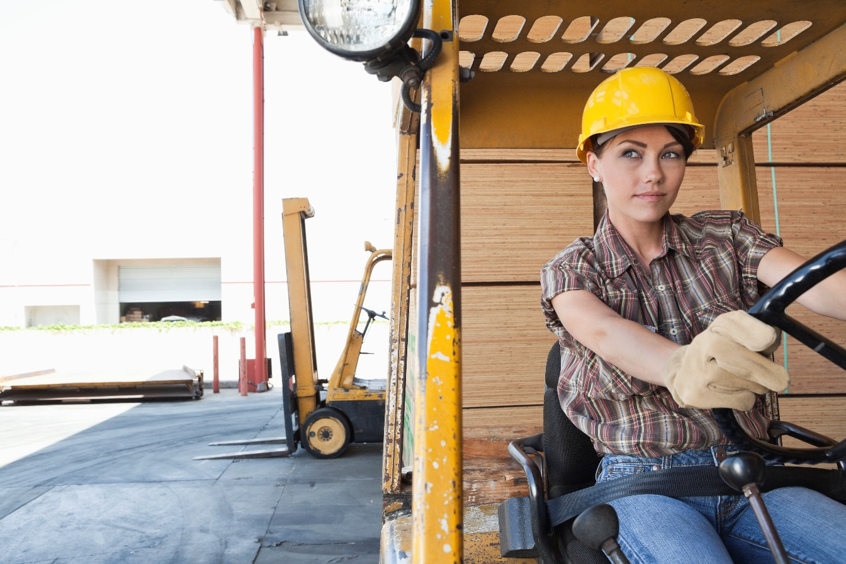

Sample Forklift Safety Program

CompWest-brandstripe.wmf

Company name here

Forklift Safety Program

Our company, <Company Name>, is committed to providing a safe and healthy work environment, and protecting our employees from injury or death caused by uncontrolled hazards in the workplace. To this end, the following forklift safety program has been established to reduce the risk of physical injury or property damage in areas where powered forklifts are in operation.

Scope

This program supports compliance with the Occupational Safety and Health Administration (OSHA) Powered Industrial Truck Standard, as found in 29 CFR 1910.178 and General Industry Safety Orders 3650(t). The forklift safety program applies to all <Company Name> employees, permanent or temporary, who are required to operate forklifts at our facility.

Powered industrial trucks, commonly called forklifts or lift trucks, are used in many industries, primarily to move materials. They can move, raise, lower or remove large objects or a number of smaller objects on pallets or in boxes, crates or other containers. In addition to forklifts, order pickers, reach trucks and electric pallet jacks also require training.

Program Responsibilities

Management is responsible for providing the safety equipment and resources necessary to implement this program and for ensuring it is followed by the <Employee Title>. The <Employee Title> is responsible for developing and implementing our forklift safety program, which includes such tasks as:

* Annually reviewing and updating this written plan
* Providing or contracting appropriate training on safe operation of all powered forklift equipment used within this facility
* Documenting all training and evaluations
* Observing forklift operations and reporting unsafe practices to the appropriate supervisor
* Reviewing copies of inspection checklists

**Supervisors are responsible for:**

* Ensuring that employees who are found to have insufficient skills or understanding of safe forklift operations receive retraining before continuing to operate any forklift
* Ensuring employees comply with all safe work practices described in this program
* Observing forklift operations in their department and correcting any unsafe practices
* Providing feedback of this program to the <Employee Title>

**Forklift operators are responsible for:**

* Operating all forklifts in a safe manner, consistent with safe work practices
* Conducting forklift inspections at the beginning of each work shift and documenting the inspection on the appropriate inspection forms
* Reporting all equipment malfunctions and/or maintenance needs to supervisors immediately
* Wearing a seatbelt at all times while operating a forklift
* Parking the lift in a safe place, removing the key and tagging or noting problems
* Notifying supervisors if they begin taking a medication that affects their ability to operate a forklift

Initial Employee Training

Operator training occurs before an employee is permitted to operate any forklift in our facility. Training will consist of a combination of formal instruction (e.g., lecture, discussion, DVD, written test of knowledge), practical training (for the forklift operator to demonstrate proficiency on the equipment), and an evaluation of the operator’s performance in the workplace. Only employees who have received training by a reputable company for the requirements of training are authorized to conduct training and evaluations.

The <Employee Title> has authorized the following people to provide forklift training:

* <Program administrator name>
* <Approved outside trainer>
* <Other staff>

All training and evaluations are documented and will include the name of the trainee, name of the trainer, the type of equipment trained to operate, and date of the training. Operators must be trained on the specific equipment they will be operating. All training will be recorded using the form in **Appendix A**.

Training Program Content

Training for forklift operators is extensive and covers both general forklift topics and workplace-specific topics.

**General forklift topics:**

* An overview of <Company Name’s> written forklift safety program
* Operating instructions, warnings and precautions for types of forklifts the operator will be authorized to operate
* Differences between forklifts and automobiles
* Forklift controls and instrumentation: where they are located, what they do and how they work
* Engine or motor operation
* Steering and maneuvering
* Visibility (including restrictions due to loading)
* Fork and attachment adaptation, operation and use limitations
* Vehicle capacity and stability
* Any vehicle inspection and maintenance that the operator will be required to perform
* Refueling and/or charging of batteries
* Seatbelt use

**Workplace-related topics:**

* Surface conditions where the vehicle will be operated
* Composition of loads to be carried
* Load stability, manipulation, stacking and unstacking
* Pedestrian traffic in areas where the vehicle will be operated
* Narrow aisles and other restricted places where the vehicle will be operated
* Hazardous locations where the vehicle will be operated
* Ramps and other sloped surfaces that could affect the vehicle’s stability
* Closed environments and other areas where a buildup of carbon monoxide or diesel exhaust could exist
* Other unique or potentially hazardous environmental conditions in the workplace that could affect safe operation

Refresher Training

Refresher training will be conducted to ensure that all operators have the knowledge and skills needed to operate forklifts safely. Refresher training will be conducted for individual operators when:

* The operator has been observed to operate the vehicle in an unsafe manner.
* The operator has been involved in an accident or near-miss incident.
* The operator is assigned to drive a different type of forklift.
* A condition in the workplace changed, which could affect safe operation of the forklift.

Refresher training will be evaluated by the < Employee Title> to gauge the effectiveness of the training.

Operator Evaluation

Each forklift operator’s performance is evaluated every three years. This evaluation includes a discussion with the operator regarding his/her experience with the forklift, an observation of the employee operating the forklift and written documentation that the evaluation was performed. All evaluation will be documented on the form located in **Appendix B**. Individuals who do not pass the evaluation will be removed from forklift operations until they successfully pass refresher training.

Forklift Safe Work Practices

The following procedures will be followed at all times:

**Equipment Inspection**

* Each shift, the forklift operator will inspect the forklift before operation. If any inspection item is determined to be damaged, broken or inoperable, the operator will notify their supervisor and authorized mechanic.
* Employee may not operate an unsafe forklift at any time.
* Forklifts will be kept in clean condition, free of dirt, excess oil and grease.

**Repair and Maintenance**

* Only a <Company Name’s> authorized mechanic or qualified vendor will perform repairs and maintenance on forklifts.
* The authorized mechanic will complete a maintenance log that identifies repairs needed and corrective actions taken for each forklift. This log will be kept at the <Maintenance Office>.
* No modifications are to be made to the forklift trucks without approval from the forklift truck manufacturer.
* If a forklift cannot be safely operated, it must be taken out of service until repairs have been made. Forklifts that have been taken out of service will be visually marked with an out of service sign (see **Appendix D**), and the ignition key will be secured in the <Maintenance Office>.
* After repairs have been completed, the forklift must be given a performance test before being returned into service to ensure that the equipment is safe to operate.

**Changing and Charging Batteries**

* Forklift batteries will be changed and charged in the designated area located at <location>.
* Equipment is provided at battery-charging areas to safely flush and neutralize spilled battery acid and electrolytes.
* Smoking is prohibited in all battery-charging areas.
* Eyewash equipment is available and maintained in all charging areas.
* Precautions will be taken to prevent open flames, sparks, and electric arcs in charging areas.
* Employees who change and service batteries and handle corrosive liquids will wear the proper personal protective equipment (PPE), including:
* Long sleeve shirt and full-length pants
* Face shield
* Safety glasses or goggles
* Chemical apron
* Chemical gloves
* The following steps must be taken when charging forklift batteries:

1. Set emergency brake.
2. Remove the battery cover.
3. Check for plugged vent caps.
4. Turn off battery charger then connect it to the battery.
5. Avoid touching battery terminals with any metal object, as this could cause a spark.
6. Once batteries are charged, turn off the battery charger.
7. Disconnect the battery charger from the battery and replace the battery cover.

**LP Gas Cylinder Changing**

* Forklift LP cylinder will only be changed in the designated area at <location>.
* All full and empty cylinders will be kept in the appropriately labeled cylinder cage when not on a forklift.
* Smoking is prohibited in all cylinder changing areas.
* Eyewash equipment is available and maintained in all changing areas.
* Precautions are taken to prevent open flames, sparks and electric arcs in changing areas.
* Employees who change cylinders must wear appropriate PPE including:
* Long sleeve shirt and full-length pants
* Face shield
* Safety glasses or goggles
* Gloves
* The following steps must be taken when changing all forklift LP cylinders:
  1. Set emergency brake and leave engine running.
  2. Close tank valve and use up remaining fuel in the fuel lines.
  3. Turn off ignition.
  4. Disconnect the hose from the tank and remove the tank.
  5. Inspect new tank for leaks and damage. Do not use if there is a leak or dents in the tank.
  6. Install the new tank and connect the hose.
  7. Open the tank valve and restart the engine.

**General Safe Work Practices**

The following procedures will be followed at all times:

* Load capacity marking on each forklift must be posted and maintained in legible condition.
* Only authorized, trained employees are permitted to operate forklifts.
* Horseplay is prohibited.
* Operators must drive with both hands on the steering wheel. Do not drive with wet or greasy hands.
* No personnel are permitted to ride as a passenger on a forklift or on the load being carried.
* A forklift may not be used to elevate a platform or pallet with persons on it, except work platforms especially designed for this purpose. Work platforms must have a standard guard rail and must be securely fastened to the forks.
* No person should stand or walk under elevated forks.
* Operators should avoid making jerky starts, quick turns or sudden stops.
* Operators may not use reverse as a brake.
* Operators must slow down on wet and slippery surfaces and at cross aisles or locations where vision is obstructed.
* Operators entering a building or nearing a blind corner must make their approach at a reduced speed, sound their horn and proceed carefully.
* Operators must give pedestrians the right-of-way at all times.
* Operators may not drive toward any person who is in front of a fixed object or wall.
* Operators may not overtake and pass another forklift traveling in the same direction.
* Operators must not put their fingers, arms or legs between the uprights of the mast, or beyond the contour of the forklift.
* Forks should always be placed under the load as far as possible. Do not lift a load with one fork.
* No load should be moved unless it is safe and secure.
* Spotters must be used when handling long lengths of bar stock, pipe or other materials.
* Compressed gas cylinders may be moved only in special pallets designed for this purpose.
* When unloading trucks or trailers, the brakes on the vehicle must be set (locked) and the wheels chocked.
* Forklifts must be safely parked when not in use. The controls must be neutralized, power shut off, brakes set, key removed, and the forks must be in a down position, flat on the surface, and not obstructing any walkways or aisles.
* A forklift will not be left on an incline unless it is safely parked and the wheels chocked.
* Only stable and safely arranged loads may be handled.
* Only loads within the rated capacity of the forklift may be lifted or moved.
* Post and enforce a set of operating rules including the appropriate rules listed in Section 3650(t) for the industrial trucks or industrial tow tractors being operated.

**Traveling**

* Facility speed limits must be observed at all times.
* Three forklift lengths (or two seconds) will be maintained between forklifts in operation.
* The forklift must be kept under control at all times.
* When vision is obstructed, the operator will slow down and sound the horn.
* If the load blocks the operator’s view, the forklift must be driven in the direction that provides the best visibility.
* Forklifts must cross railroad tracks at a diagonal.
* Forklifts must be parked 8 feet or farther from the center line of the railroad tracks.
* The forklift must be driven with the load upgrade when driving on ascending or descending grades greater than 10%.
* Dock boards and bridge plates will be properly secured before they are driven over.
* When the forklift is not carrying a load, the operator must travel with the forks as low as possible (maximum of 3 inches on paved surfaces). When carrying a load, it should be carried as low as possible (consistent with safe operation, 2 to 6 inches above the surface).
* The forks should not be operated while the forklift is traveling.
* On a downgrade, the load shall be last, and the forks raised only enough to clear the surface.

Periodic Program Review  
The Forklift Safety Program and procedures are reviewed annually. The review is documented on the form located in **Appendix C**.

Appendix A – Forklift Operator Training Record  
The following individual received training on <Company Name’s> forklift safety program for <specific equipment type>.

|  |  |
| --- | --- |
| PRINT NAME | SIGN NAME |
|  |  |
|  |  |
|  |  |
|  |  |
|  |  |
|  |  |
|  |  |
|  |  |
|  |  |
|  |  |

The undersigned conducted training in accordance with <Company Name’s> forklift safety program.

|  |  |
| --- | --- |
| Print Instructor’s Name |  |
| Instructor’s Signature |  |
| Instructor’s Title |  |
| Date of Training |  |
| Equipment Type |  |

Appendix B – Forklift Operator Evaluation

Forklift Operator Name: _________________________________ Forklift Model/#: ______________

Location: _____________________________________________ Date: _______________________

Evaluator’s Name: ____________________________________________________________________

|  |  |  |
| --- | --- | --- |
| BEFORE STARTING | ACCEPTABLE | NOT ACCEPTABLE |
| Conducts pre-shift inspections per operating manual and uses form/checklist |  |  |
| Looks for damage and reports problems |  |  |
| TRAVELING | **ACCEPTABLE** | **NOT ACCEPTABLE** |
| Wears safety belt or harness and required PPE |  |  |
| Keeps body within operator compartment |  |  |
| Operates forklift in accordance with operating compartment |  |  |
| Looks in direction of travel before and while moving |  |  |
| Uses forklift lighting in dark areas |  |  |
| Carries forks/load 3 to 6 inches above ground |  |  |
| Smooth starts, stops and direction changes |  |  |
| Sounds horn at blind corners – slows or stops as necessary |  |  |
| Turns wide to see down travel path |  |  |
| Travels right of center allowing room for step out |  |  |
| Uses extreme caution when meeting pedestrians |  |  |
| Leaves three or more lengths for stopping when behind another vehicle |  |  |
| Stays well away from drop-offs |  |  |

|  |  |  |
| --- | --- | --- |
| LOAD HANDLING | ACCEPTABLE | NOT ACCEPTABLE |
| Never handles loads in excess of forklift capacity or load tiers above LBR height |  |  |
| Uses attachments according to manufacturer’s instructions |  |  |
| Approaches loads properly |  |  |
| Does not raise or lower forks while traveling |  |  |
| Does not turn with forks elevated |  |  |
| Keeps mast vertical (load level) when high stacking |  |  |
| Enters and exits pallets properly (forks level and properly spaced) |  |  |
| Travels in reverse when load partially obstructs visibility |  |  |
| Travels with loads 6 to 12 inches above the ground and tilted back to stabilize the load (If the load represents a hazard of sliding off the forks during forward braking, e.g., metal on metal, then additional tilt may be necessary.) |  |  |
| Handles long loads with forks spread wide and uses spotters |  |  |
| Aligns loads properly in racks or stacks |  |  |
| PEDESTRIAN ISSUES | **ACCEPTABLE** | **NOT ACCEPTABLE** |
| Slows, honks and yields to pedestrians at corners and step outs |  |  |
| Allows no pedestrians near operating forklift, particularly in trailers or railcars |  |  |
| Watches for pedestrians in tail swing area |  |  |
| Honks before passing pedestrians |  |  |
| Allows no pedestrians beneath load or to ride on forklift, forks or pallet |  |  |

|  |  |  |
| --- | --- | --- |
| TRAILER AND RAILCAR LOADING | ACCEPTABLE | NOT ACCEPTABLE |
| Trailer/railcar properly chocked – jack stand used when needed |  |  |
| Slides axles to rear |  |  |
| Inspects floor |  |  |
| Checks dockboard capacity – Installs correctly |  |  |
| Takes steps to prevent tractor trailer pull away |  |  |
| Uses lighting aids |  |  |
| Looks into trailer/railcar before entering with EACH load |  |  |
| RAMPS/INCLINES | **ACCEPTABLE** | **NOT ACCEPTABLE** |
| Travels with load upgrade and takes precautions for visibility |  |  |
| Travels empty with counterweight upgrade |  |  |
| NEVER turns on ramps or inclines |  |  |
| PARKING | **ACCEPTABLE** | **NOT ACCEPTABLE** |
| Lowers forks, sets brake, neutralizes transmission controls, chocks wheels on slope and shuts off LPG when parking for extended periods of time |  |  |
| Parks in location not blocking firefighting equipment, electrical panels, doorways, stairways, ladders, emergency exits or railroad tracks |  |  |
| Shuts off engine if moving more than 25 feet from forklift or moving out of sight of forklift |  |  |

|  |  |  |  |
| --- | --- | --- | --- |
| LPG/CNG | ACCEPTABLE | NOT ACCEPTABLE | |
| Turns off forklift |  |  | |
| Allows no open flames or ignition sources in refueling area |  |  | |
| Wears required PPE |  |  | |
| LPG: Removes tanks and stands bottle vertically to refuel |  |  | |
| If authorized, fills in accordance with regulations |  |  | |
| Uses outage valve to determine fill level and does not overfill |  |  | |
| Seeks assistance replacing bottle on forklift and uses locator pin and hole to properly index bottle |  |  | |
| Cleans up spills |  |  | |
| BATTERY CHARGING | **ACCEPTABLE** | **NOT ACCEPTABLE** | |
| Turns off forklift |  |  | |
| Allows no open flames or ignition sources in refueling area |  |  | |
| Wears required PPE |  |  | |
| Opens battery lid – does not remove caps |  |  | |
| Does not plug running charger to battery |  |  | |
| Locates forklift properly, uses charging device in accordance with manufacturer’s instructions and securely reinstalls battery and retention device |  |  | |
| ADDITIONAL OBSERVATIONS AND COMMENTS | | |
|  | | |

Appendix C – Annual Evaluation Report

|  |  |
| --- | --- |
| Date of Evaluation: | Evaluated By (list all present): |
| Written program reviewed: Yes No | |
| Comments on written program: | |
| The following specific procedures have been reviewed: | |
| The following specific procedures were modified: | |
| The following specific procedures were added: | |
| A review of the accident reports and injury and illness reports were made: Yes No | |
| The following additional expense(s) resulted from failure to properly operate a forklift: | |
| Comments: | |

Appendix D – Out of Service Sign

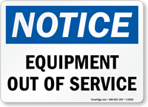

Appendix E – Load Capacity Sign

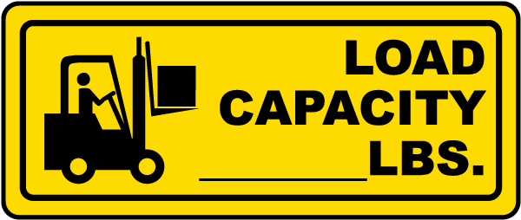

Forklift Truck Daily Checklist  
  
Truck #: _______________________ Inspected by: ___________________

Date: _________________________ Time: __________________________

|  |  |  |  |  |
| --- | --- | --- | --- | --- |
|  | **Condition** |  |  |  |
| **Item** | **Good** | **Fair** | **Needs Repair** | **N/A** |
| Wheels and tires |  |  |  |  |
| Mast |  |  |  |  |
| Tilt controls |  |  |  |  |
| Horn |  |  |  |  |
| Steering |  |  |  |  |
| Gauge(s) condition |  |  |  |  |
| Head and tail lights |  |  |  |  |
| Safety beeper |  |  |  |  |
| Back-up alarm |  |  |  |  |
| Hydraulic cylinder |  |  |  |  |
| Battery |  |  |  |  |
| Fuel |  |  |  |  |
| Fire extinguisher |  |  |  |  |
| Seat |  |  |  |  |
| Brakes |  |  |  |  |
| Emergency brake |  |  |  |  |
| Accelerator |  |  |  |  |
| Shift mechanism |  |  |  |  |
| Capacity plate |  |  |  |  |

Repairs completed by: ___________________________ Date: ___________________

Daily Inspection Checklist – Electric Forklift Truck

|  |  |
| --- | --- |
| **KEY OFF PROCEDURES**   * Vehicle inspection * Overhead guard * Hydraulic cylinders * Mast assembly * Lift chains and rollers * Forks * Tires * Examine the battery * Check the hydraulic fluid level |  |
| **KEY ON PROCEDURES**   * Check the gauges * Hour meter * Battery discharge indicator * Test the standard equipment * Steering * Brakes * Front, tail and brake lights * Horn * Safety seat (if equipped) * Check the operation of load-handling attachments |

Daily Inspection Checklist – Propane Forklift Truck

|  |  |
| --- | --- |
| **KEY OFF PROCEDURES**   * Vehicle inspection * Overhead guard * Hydraulic cylinders * Mast assembly * Lift chains and rollers * Forks * Tires * LPG tank and locator pin * LPG tank hose * Gas gauge * Check engine oil level * Examine the battery * Check the hydraulic fluid level * Check engine coolant level |  |
| **KEY ON PROCEDURES**   * Test the front, tail and brake lights |
| **ENGINE RUNIING PROCEDURES**   * Check the gauges * Oil pressure indicator lamp * Ammeter indicator lamp * Hour meter * Water temperature gauge * Test the standard equipment * Steering * Brakes * Front, tail and brake lights * Horn * Safety seat (if equipped) * Check the operation of load-handling attachments * Check the transmission fluid level |