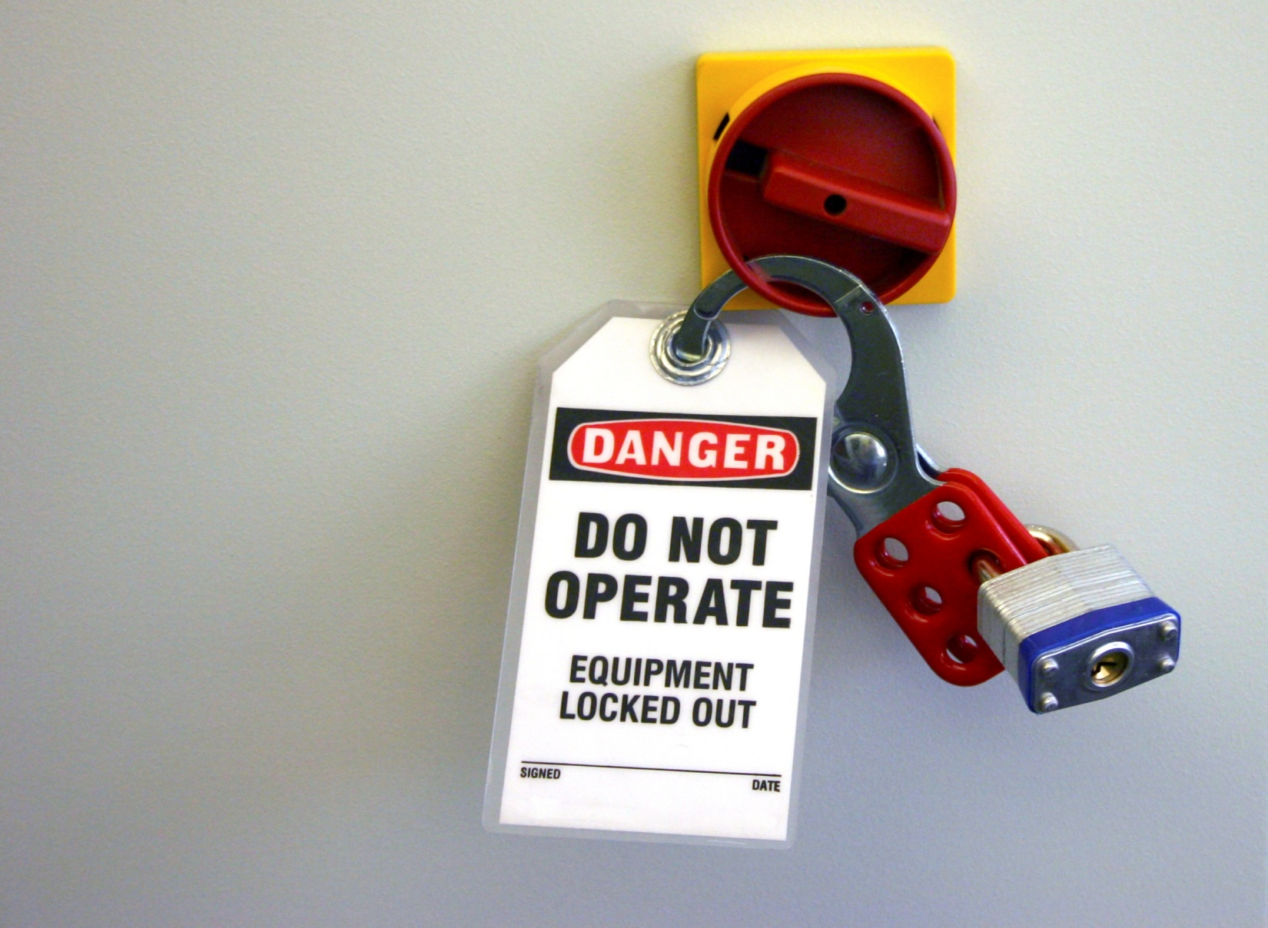
Sample Lockout / Tagout Program
Company name here

In our workplace there are machines and equipment that could cause accident or injury if they are not operated correctly. Our management has developed a Lockout/Tagout program to control the release of hazardous energy created by the unexpected start up of machines or the release of uncontrolled energy. The Lockout/Tagout program and procedures have been established to protect our employee health and ensure that while shutting down equipment for maintenance, service, etc… that the equipment is isolated from its energy source, making it inoperable prior to the service or maintenance work is performed.

Our Lockout/Tagout Administrator is: (Required)

This is the identified person that will oversee and implement our company Lockout/Tagout (LOTO) program. The Lockout/Tagout program is herein referred to as LOTO.

The following machine and equipment tasks require LOTO procedures:
- Installing
- Setting Up
- Adjusting
- Repairing
- Inspecting
- Modifying
- Cleaning
- Lubricating
- Un-jamming equipment and parts
- Changing Tools
These tasks may not require LOTO procedures. If you are unsure ask your supervisor:
- Work performed on cord, if unplugging the equipment controls all the energy, and the plug remains under the continuous control of the employee performing the maintenance or modification.
- Minor tool adjustments and other minor service activities that take place during normal production may not be required in LOTO procedures, provided the adjustments and activities are routine, repetitive and integral to the use of equipment.
Below is list of our company LOTO steps. Our LOTO program requires that all employees performing LOTO duties are trained and authorized to perform LOTO duties by the designated company administrator.
1. AUTHORIZED employees will notify AFFECTED employees that the LOTO program will be implemented and which machines or equipment will be locked out.
2. If required, obtain and follow the equipment specific written procedures. If a new written procedure is required contact a supervisor.
3. EMPLOYER TO MODIFY STEP 3 TO ADDRESS EQUIPMENT AND MACHINE SPECIFIC TO THEIR OPERATIONS
List what you must know regarding types of hazardous and controls before turning or any machine or equipment:

a. See examples and definitions provided at the bottom of sample program.
i. Is mechanical, hydraulic, pneumatic, chemical, thermal, other?
ii. What is the energy hazard and how will it be controlled?

4. Shut down the machine or equipment using its normal and standard stopping procedures.
5. Operate the switch, valve and/or other energy isolating devices so that the equipment is completely isolated from all of its energy sources.
6. Attach LOTO devices to the energy-isolating devices of the machine or equipment.
7. Take the following steps to guard against energy left in the equipment after it has been isolated from its energy source:
a. Inspect all moving parts
b. Install ground wires
c. Relieve trapped pressure
d. Bleed lines
e. Release/Block spring-driven
f. Open valve vent parts
g. Block/brace parts that could fall
h. Drain process pipes
8. Use approved and appropriate test equipment to test circuit elements and electrical parts of equipment to which employees will be exposed, and verify that the circuit elements and equipment parts are de-energized.
The test shall determine if any energized condition exists as a result of inadvertently induced voltage or unrelated voltage back-feed though specific parts of the circuit have been de-energized and presumed to be safe.
Press all start buttons and any other activating controls on the equipment itself.
9. Perform the required maintenance.
10. Observe safe start up procedures
Before removing LOTO devices, restarting equipment or testing equipment:
a. The AUTHOURIZED employee will ensure that the equipment parts/components are intact, lines have been reconnected and safeguards are in place.
b. Notify the AFFECTED employees that the LOTO devices will be removed.
c. Ensure that all tools and materials have been removed from the equipment and area.
d. Ensure that all switches, valves and energy controls are still in the “off” position.
e. Ensure that all the affected employees are away from the equipment.
f. Remove the LOTO devices.
g. Test the equipment.
Multiple Lock Out Situations:
- In a multiple LOTO procedure, each person working on the machinery or equipment must place a LOTO tag or device on the equipment. If the energy isolating device will not accept multiple locks or tags, a multiple lockout device called a hasp may be utilized.
- The locks and tags must be placed in a way that prevents the energy restoration to the machinery or equipment until every lock or tag is removed.
- As each employee involved no longer needs to maintain LOTO protection, the responsible employee removes their own lock and tag.
- A supervisor is responsible for determining appropriate group LOTO.
- A supervisor must hold a group meeting with all members of the LOTO covered procedure.
- The supervisor must describe the tasks that will be performed.
- The supervisor must delegate primary responsibility to a designated authorized employee
- Each member of the group must be trained and authorized.
- The designated authorized employee is responsible for ensuring that each step of the general or equipment-specific written procedures is completed.
- The designated authorized employee must apply their individual LOTO lock(s) and tag(s) to the energy controlling device(s) and indicate that a group lockout is in effect.
- If there is an employee change in the group while work is in progress, the designated authorized employee must inform any new group member that a group lockout is in place.
- Anyone leaving the group before the servicing, maintenance or modifications are completed must notify the designated authorized employee. The leaving group member must communicate the status of their activities to the designated authorized employee.
Emergency Removal of Lock Out
Under extreme and emergency conditions a supervisor has authority to remove LOTO devices installed by the authorized employees when that employee is not available to remove the device.
- The supervisor must verify that the authorized employee is no longer at the work place.
- The supervisor should make every reasonable effort to contact the employee at home.
- If the employee is reached the supervisor will let the employee know that the LOTO device is being removed.
- The supervisor must verify that it is safe to remove the LOTO device.
- Upon verification, the supervisor will use the emergency key to remove the LOTO device, or cut the LOTO device if no key is available.
- The supervisor will present the authorized employee with the removed lock immediately upon return to work place with an informed reason for the emergency removal.

Shift Changes
Due to a lack of communication, accidents can occur shortly after a shift change.
- During a shift change, the departing employee should meet arriving employee at the LOTO device.
- The arriving authorized employee should place their LOTO device and tag on the equipment before the departing employee removes their lock or tag.
Outside Contractors
Whenever outside contractors are on site and/or engaged in activities that require compliance with the LOTO standard, the on-site supervisor and the outside employer must inform one another of their LOTO procedures.
Periodic Inspections
The Program Administrator or a designated employee is responsible for conducting an annual inspection and must certify that inspections have been conducted.
The certification of this process identifies the machine or equipment, the date of the inspection, which employees were involved in the LOTO procedure and the name of the employee completing the inspection.

LOTO Definitions and Facts
What is hazardous energy?
Hazardous energy is the unexpected or stored energy that could cause injury while equipment is being serviced, repaired or maintained.
The types of LOTO energy:
- Mechanical
- Hydraulic
- Pneumatic
- Chemical
- Thermal
- Other
What is stored energy?
Stored energy is energy that may be contained in springs, elevated machine parts, rotating fly wheels, hydraulic systems, air, gas, water, steam and water pressure that will be dissipated or restrained by methods such as grounding, repositioning, blocking, bleeding, etc.
What are examples of dangers/controls associated with electrical energy?
- Shock and/or burn could result from contact with exposed conductors, line voltage or high voltage equipment.
- Flying parts or fire could result if a circuit is shorted.
- Electrical energy hazards can be controlled at the circuit breaker or main switch.
What are examples of dangers/controls associated with pneumatic energy?
- High velocity air impingement can inflict injuries to the eyes, ears, etc. Air flow can cause small objects to become airborne missiles.
- Compressed air can be controlled at the shutoff valve, cylinder control valve or the air line valve.
What are examples of dangers/controls associated with chemical energy?
- Chemical gas or liquid can produce illness or injury through its toxicity, flammability, corrosively or reactivity.
- Chemical gases or liquids can be controlled from accidental release by turning a cylinder valve or the gas line control valve.

What are examples of dangers/controls associated with mechanical energy?
- A variety of machines can inflict tissue or skeletal injury through crushing, laceration or impalement.
- Mechanical energy can be controlled through the main electrical switch, plug, circuit breaker or blocking.
What are examples of dangers/controls associated with thermal energy?
- Thermal energy is heat generated energy whether from electrical resistance, mechanical work, or chemical reactions.
- Thermal energy can be controlled by the main electrical switch, electrical plug control, circuit breaker, steam valve, fluid line valve and shielding.
LOTO Devices
Durable – LOTO devices must withstand the environment to which they are exposed for the maximum duration of the expected exposure. Tagout devices must be constructed and printed so that they do not deteriorate or become illegible, especially when used in corrosive or wet environments.
Standardized – Both LOTO devices must be standardized according to either color, shape, or size. Tagout devices must also be standardized according to print and format.
Tags Must:
- Be standardized
- Include the authorized employee’s name
- Be legible and understandable
- Be securely attached
- Include a clear warning
Tag Warnings:
- Do Not Open
- Do Not Start
- Do Not Energize
- Do Not Operate
Leading Causes of Injuries
- Failure to shut off equipment
- Failure to disconnect from power source
- Unexpected restarting of equipment
- Failure to clear work area before restarting

