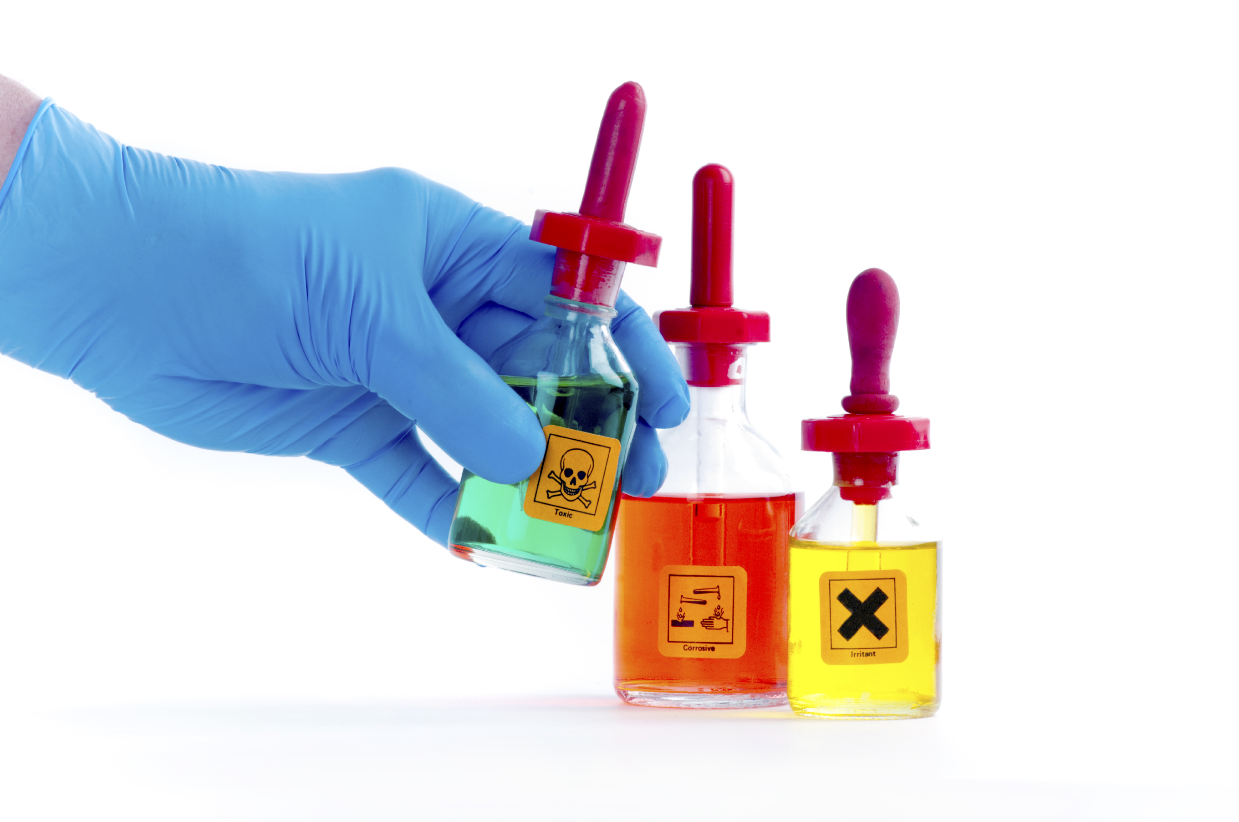
Sample Hazard Communication Program
Company name here

Company Hazard Communication Program
To enhance our employees’ health and safety, our company has developed, implemented, and maintains a hazard communication program that meets both OSHA 29 CFR 1910.1200 and Title 8 of the California Code of Regulations (T8 CCR) Section 5194 Hazard Communication Standard.
We provide information about the hazardous substances in our workplace, the associated hazards, and the control of these hazards through a comprehensive written hazard communication program that will control and limit chemical exposures which may cause or contribute, from improper use or unsafe handling, serious health effects, side effects, injuries, irritations, rashes or burns. Some chemicals are also safety hazards and have the potential to cause fires, explosions, and/or other serious accidents.
With clearly identified procedures outlined in our workplace it is company intention to: identify and control hazardous substances present in the workplace, promote safe and effective work practices, reduce the possibility of injury and workers’ compensation losses and comply with the law.
This program establishes standardized requirements to ensure that the hazards of all chemicals handled, used, and/or stored in the workplace are classified and that this hazard information is communicated and understood by all affected employees by means of Globally Harmonized System (GHS) labeling, safety data sheets (SDS’s), and employee safety training. Through this program, our employees will receive the necessary hazard information and our company will take the necessary steps to reduce exposures and implement proper work practices. Steps include:

- Assignment of Responsibilities
- List of Hazardous Chemicals
- Annual Chemical Review
- Container Labeling
- Review of Tasks that Involve Hazardous Chemicals
- Contractor Communication
- Program Audit
- Recordkeeping
- Safety Data Sheets (SDS)
- Employee Training

I. ASSIGNMENT OF RESPONSIBILITIES
The Program Administrator, with support of management and employees, will oversee our Hazard Communication Program.
Program Administrator
has been assigned as Program Administrator.
The Program Administrator is responsible for the development and administration of the Hazard Communication Program and has authority to make necessary decisions to ensure its success and has the complete authority to halt any operations where there is a risk of employee injury associated with the use of any chemical in the workplace. The Program Administrator will review and evaluate this Hazard Communication Program on an annual basis, as there are changes to OSHA standards, when there is an accident or near miss related to chemical usage/exposure, or any time the program contents do not appear to be adequate.
In addition, the Program Administrator will:
- Maintain a current inventory of hazardous chemicals present in the workplace and perform an annual review of all chemicals in the workplace
- Obtain and maintain safety data sheets (SDS’s) for all chemicals in the workplace
- Ensure all hazardous chemicals in the workplace are appropriately labeled to meet GHS requirements
- Train employees to understand and recognize labels, warnings, color-coding, and signs. etc. that are affixed to containers
- Train employees to understand the elements of a safety data sheet (SDS)
- Train employees in the safe use, handling, and storage of hazardous chemicals
- Train employees to understand and recognize potential exposures, appropriate work procedures and personal protective equipment, and appropriate responses to accidental exposure
- Communicate to contractors the hazards to which their employees may have exposure and ensure that contractors employ appropriate safeguards for their work
- Review tasks that involve hazardous chemicals and develop appropriate safeguards for performance of those tasks
- Assess the hazards and protective measures associated with non-routine tasks involving hazardous chemicals
- Conduct periodic inspections to ensure work practices are being adhered to
- Investigate and document any chemical injuries, exposures or accidents
- Ensure proper medical consultations and examinations for workers who suspect overexposure to hazardous chemicals and maintain medical records relating to consultations, examinations, and medical surveillance as required by law
- Provide, as necessary, chemical information to state and local regulatory agencies
- Maintain records to document compliance with the program
- Apply above protocol to chemicals used for one-off or non-routine tasks

II. INVENTORY OF HAZARDOUS CHEMICALS
The Program Administrator will develop and maintain an inventory of the hazardous chemicals known to be present in our workplace. All hazardous chemicals used or stored on-site will be identified and their common uses, quantity, and location documented. This inventory will be organized using the product identifier that is referenced on the safety data sheet (SDS). The list will be compiled for the workplace as a whole and may also be compiled for individual work areas.

III. ANNUAL CHEMICAL REVIEW
The Program Administrator will ensure that the inventory of our company's hazardous chemicals is easily accessible and available to our employees at all times. At least annually, the Program Administrator will initiate a review of all chemicals purchased, used, and/ or stored to verify that they are on the current inventory of hazardous chemicals; that the SDS information is current; and that training, labeling, and recordkeeping requirements are being met.
Immediately after new chemicals are brought into the workplace, the inventory will be updated, SDS’s will be obtained and made accessible, and labeling requirements will be met. When the use or storage of a chemical is discontinued, the Program Administrator or designated associate will continue to maintain the SDS for recordkeeping purposes and add the product to a List of Obsolete Safety Data Sheets.
In the case where a chemical exposure was previously unknown or a one-off situation is determined, the Program Administer will review exposures, obtain SDS and train exposed employees as required.

IV. SAFETY DATA SHEETS (SDS)
The Program Administrator will ensure that required safety data sheets (SDS’s) are obtained, preferably prior to the purchase and retained for each hazardous chemical used or stored by our company. Chemicals for which the SDS has not yet been received will not be used by an employee until the SDS is obtained and reviewed.
It is the responsibility of the Program Administrator or designated associate to maintain the most recent copy in the active SDS file, and to ensure that it is readily accessible to all employees, designated representatives, and OSHA officials.

V. CONTAINER LABELING
The Program Administrator is responsible for the following:
- Verifying that all containers in which hazardous chemicals are received or stored are prominently labeled, tagged, or marked in legible English with the required information.
- Ensuring that labels on incoming containers of hazardous chemicals are legible and not removed or defaced at any time unless immediately replaced with a compliant in-house label.
- Ensuring that secondary containers, used for regular storage and use of chemicals, also meet labeling storage requirements.
- If employees speak other languages, ensuring that labels provide information in their language.
Exceptions to workplace container labeling requirements include the following:
- Portable containers holding hazardous chemicals intended for immediate use by the employee who transferred the chemical from its original container and which are under the complete control of that employee at all times.
- If our company decides to use signs, placards, process sheets, batch tickets, operating procedures, or other such written materials in lieu of affixing labels to individual stationary process containers, the alternative method must identify the containers to which it is applicable and convey the information required to be on a label. Our company will also ensure that the written materials are readily accessible to the employees in their work area throughout each work shift.

VI. REVIEW OF TASKS THAT INVOLVE HAZARDOUS CHEMICALS
It is important that our company and employees understand the hazards presented by chemicals used or stored in our workplace. The Program Administrator will oversee development and maintenance of written procedures detailing appropriate actions and safeguards for control of all hazardous chemical exposures. The Program Administrator will review any new procedure involving hazardous chemicals for potential exposure hazards.
All procedure reviews and approvals will occur before introducing a chemical into work processes. The written procedures will include:
- Specific chemical hazards
- Personal protective equipment or safety measures an employee must use to protect against these hazards
- Measures taken to lessen the hazards including ventilation, respirators, and emergency procedures
- Methods and observation techniques used to determine the presence or release of hazardous chemicals in the work area

VII. EMPLOYEE TRAINING
The Program Administrator will ensure that Hazard Communication Program training is provided to all employees at the time of their initial assignment, whenever new chemicals are introduced into their work area or when, if applicable, an employee is transferred into a new work area. Training is required for full-time, part-time, and temporary employees.
Employee training sessions will include the following:
- Description of operations in the employees' work area where hazardous chemicals are present.
- The physical, health, simple asphyxiation, combustible dust and pyrophoric gas hazards, as well as hazards not otherwise classified, of the chemicals in the work area.
- Location and availability of the written Hazard Communication Program including the inventory of hazardous chemicals; explanation of the labels received on shipped containers and the workplace labeling system used by our company; and the SDS, including the order of information and how employees can obtain and use the appropriate hazard information.
- Encouragement for employees to familiarize themselves with the chemicals they use and to update themselves as new or revised SDSs arrive, which is done before an employee works with a chemical to ensure maximum understanding and employee protection.
- An explanation of what an SDS is, how to read an SDS (e.g., what information each section contains and where to look for specific information), and where SDSs are located.
- An explanation of how to relate information on SDSs to the information on container labels (e.g., physical properties and health hazards).
- An explanation of steps taken to protect employees including the use of personal protective equipment (PPE), why PPE is important, and the SDS section detailing the PPE for each chemical.
- An explanation of safe handling procedures for the chemicals the employees may have exposure to and where the information is referenced on the SDS.
- The measures employees can take to protect themselves from these hazards, including specific procedures the company has implemented to protect employees from exposure to hazardous chemicals, such as appropriate work practices, emergency procedures, and personal protective equipment to be used.
- An explanation of the hazard pictograms found on labels and any caution signs or other warning signs used in the work area.
- Methods and observations that may be used to detect the presence or release of a hazardous chemical in the work area (e.g., monitoring conducted by the employer, continuous monitoring devices, and visual appearance or odor of hazardous chemicals when being released).
- Directives to identify the potential hazards associated with non-routine tasks before the employees go to work on the task.
- An explanation to employees of what to do in case of mechanical accidents (e.g., equipment failure): spills, leaks or releases of chemicals; and ingestion/inhalation/ injection/ absorption.
- Emergency procedures to follow when hazardous chemicals are involved.
Training provided may include video/DVD, slide presentations, visual demonstrations, or other appropriate teaching techniques. General training on hazardous chemicals is not sufficient. All training must be documented. It is necessary to effectively communicate to employees the hazards associated with the chemicals used in each work area.
Although the HCS does not specify a training frequency, best practices dictate that the topic of hazard communication training should be reviewed with employees at least annually. General and job-specific information needs must also be considered. Additional training by department, by hazard category, or by complete coverage of the HCS will be considered and implemented as necessary.

VIII. CONTRACTOR COMMUNICATION
Before beginning any work in the facility. Our company will ensure that contractors and their employees have been provided with:
- A list of hazardous chemicals to which they may be exposed while in the facility
- A description of protective measures needed or provided to prevent hazardous exposure
- Information regarding where the SDS’s are located and any necessary safety precautions
- An opportunity to answer any safety or health related questions
Additionally, if a contractor introduces hazardous chemicals into the company work space, the contractor will be required to identify each chemical, provide an SDS for each chemical, and ensure the chemical is appropriately labeled. The contractor should have its own written Hazard Communication Program and should have trained its employees. Our management and employees have a right to examine SDS’s of products used by contractors.

IX. RECORDKEEPING
The Program Administrator is responsible for maintaining the following records:
- The Hazard Communication Program document
- A current and complete inventory of hazardous chemicals
- SDS’s corresponding to the current inventory of hazardous chemicals
- An SDS/MSDS obsolete file that includes an index of all obsolete hazardous chemicals and their corresponding SDSs (retention requirement is not less than 30 years), the dates of use and the date the chemical was removed from the facility, and the location(s) where the obsolete chemical was used or stored
- Results of the annual chemical review
- (Written training records for each employee detailing the extent of training received and the date it was received (retention requirement is duration of employment)

Training and Reference Tools

- Chemical Inventory List

- Hazard Communication Training Record

- OSHA Quick Card – Standard Pictogram

- OSHA Quick Card – Standard Labels

- OSHA Quick Card – Safety Data Sheets
Chemical Inventory List
Product Name | Id Number | Manufacturer Info | SDS on File

Hazard Communication Training Record

Date:
Presenter:
Topic:
Employees in Attendance:

